**PURBANCHAL UNIVERSITY**



**KIST COLLEGE OF INFORMATION TECHNOLOGY**

**THIRD SEMESTER PROJECT ON**

**“Futsall Management System”**

In the partial fulfillment for the requirement of the 3rd Semester Project-III (Subject Code-BIT278CO`) in the Completion of Bachelor of Information Technology (BIT) degree at KIST College of information and Technology, under Purbanchal University.

**SUBMITTED BY SUBMITTED TO**

**1. Shankar Shrestha S.N:- 333371 PURBANCHAL UNIVERSITY**

**Date: 30 May 2018**

**Abstract**

The purpose of the Futsall management system to facilitate the customers to book Futsal field and to search the data of the football fields’ information and administrators can have facilities to store and update the customers’ information. Futsal Field Management System has been developed with Visual Studio 2014 together with SQL Server 2014 and designed the system. A database system with the format in English is the most useful which can be able to solve the errors in the work of Futsal Field Management System. This database system can be used in the real work which can be convenient for customers and administrators.

**Acknowledgement**

We take this opportunity to express our profound appreciation and unfathomable regards to the Information Technology (IT) department for this commendable guidance, monitoring and constant encouragement throughout the course of this project. The help and guidance given by shall carry us a long way, in the journey on which we are about to embark.

We also take this opportunity to express a deep sense of gratefulness to Mr. Anaya Upadhyay for his amiable support, valuable information and guidance, which helped us in completing this task throughout its various stages. We also want to thank our coordinator Mr. Deepak khadka who helped us a lot during the complete project by giving us his precious time. We are also indebted to all members of KIST College, for the valuable suggestions and help provided by them in their in their respective fields. We are grateful for their cooperation during the period of our project.

Finally we would also like to express lots of thanks to **PURBANCHAL** **UNIVERSITY** for designing such a wonderful course structure. It will help us to get more knowledge in the field of Information Technology & help us to have a bright future in the field of technology.

We hope our University will accept this attempt as a successful project.

**Student’s Declaration**

We following students, hereby declare that the Project Report titled

"**Futsall Management System"** is a result of our own work and our indebtedness to other work publications, references, if any, have been dully acknowledged. If we are found guilty of copying any other report or published information and showing as our original work, we understand that we shall be liable and punishable by Purbanchal University, which may include fail in examination, ‘Repeat study and re-submission of the report' or any other punishment that Purbanchal University may decide.

We further certify that this Project submitted in partial fulfillment of the requirement for the award of Bachelor in Information Technology (BIT) of the Purbanchal University is our original work and has not been submitted for award

|  |  |  |  |
| --- | --- | --- | --- |
| S.N | Name | Symbol No. | Signature |
| 1. | Shankar Shrestha | 333371 |  |

of any other degree or other similar title or prizes.

Date: 30 May 2018

**Examiner’s Certification**

|  |  |  |
| --- | --- | --- |
| S.N. | Name | Symbol No. |
| 1 | Shankar Shrestha | 333371 |

This is to certify that the project entitled “**Futsal Management System** “has been successfully completed by

in partial fulfillment of Degree of Bachelor of Information Technology of Purbanchal University during the academic year 2017 under the guidance of Mr. Anaya Upadhyay.

…………………………………………………………………………….

Department of Science and Technology

**KIST College of Information Technology**

PURBANCHAL UNIVERSITY

**To Whom It May Concern**

This is to certify that Mr. Shankar Shrestha of Bachelor in Information Technology (BIT) has studied as per the curriculum of BIT 3rd semester and completed the project entitled “**Futsall Management System**”. This project is the original work of that Mr. Shankar Shrestha was carried out under the supervision as per guidelines provided by Purbanchal University and certified as per the student’s declaration that project “Futsall Management System” has not been presented anywhere as a part of any other academic work.

The details of the student are as follows:-

|  |  |  |
| --- | --- | --- |
| S.N. | Name | Symbol No. |
| 1 | Shankar Shrestha | 33337 |

Course Semester: - Third Semester

Subject:-Project-III

Subject Code:- BIT278C0

**Table of Contents**

**Topic Page no.**

1. Background
   1. Abstract of the project 1
   2. Introduction 2
   3. Objective of the project 2
   4. Future of the project 3
   5. Process in the project 3
   6. Introduction to language used 4
2. System Requirements
   1. Hardware Requirement 5
   2. Software Requirement 5
3. System Design
   1. Flowchart 6
   2. Data Flow Diagram 7-8
   3. ER-Diagram 9
4. Snapshots 10-12
5. Limitations 13
6. Conclusion 14
7. Bibliography 15

**1.BACKGROUND**

* 1. **Abstract of the project**

The “Futsal Management System” undertaken as a project based on relevant technologies. The main purpose of this project is to develop the sport to provide the ground information to the player. This project has been developed to carry out the processes easily and quickly, which is not possible with the manual system. This project is developed using C # language, and is meant for booking the ground , providing print report, getting instant information of futsal and update. We have made this project interactive and easy to use. We have mainly focused on different types of problem that occur in normal payment and booking system. This project improves the performance of a software by reducing time and improving the quality of services and related processes. Thus it provides the complete solution for the current traditional system.

As we are beginners and have no practical experience in the field of software development and more over the Payment /Booking record system is very wide. So, we limit the scope of our project by computerizing the following field of the payment and booking record system:

* Available customer record.
* Providing Todays Game information.
* Update customer record.
* Providing daily game information.
* Available booking for customer.
* Fetch the data from database.
* Available filter in datagrid.
* Available payment system.
* Available current Date, Day and Time.
  1. **Introduction**

In this current global society is a society of information technology (IT). The evolution of information technology has been changed so quickly and has become extremely complex to develop countries consistently with the era and adapt to the ASEAN Economic Community so that information technology has come to play an important role on people's life which have applied technologies in areas such as industry, finance, business, education, communication and creating a competitive advantages through trading with other countries. In Thailand it is steaming in the countries that give priority to information technology which is founding countries to national economic, social wisdom and learning (Knowledge-based Economy) by encouraging technology which has been used in various activities both in the public and private sectors. The database has a role in the various aspects taking technology to help in business. It can also build the business that can be externally recognized easily to another current international business which is very high competition at the present. International business has a lot happening and it must have the facility to get more customers whether it's booking system that provides the information to customers and get attraction from them. So the group has recognized the importance in making a booking system of futsal stadium and improves the system performance to get better jobs. There is also a reliable data and saves time in managing data which can be added to customer services in the future. In the fast growing field of software engineering or information technology and development and even more rapidly growing sector of software development the future is hard to predict. We are working with this game as our software project III and as part of our degree we choose this type of work for doing better with development cycle, development period, graphics, scripting, adopting new technology, animation.

In general software project is a project focusing on the creation of software. Consequently, Success can be measured by taking a look at the resulting software. In a project, the product is about futsal management system. But and here comes the point: A futsal management system is much more than other management software. It has to provide content to become enjoyable.

“**Just like a web server: without content the server is useless, and the quality cannot be measured.**”

This has an important effect on the project as a whole. The software part of the project is not the only one, and it must be considered in connection to all other parts: The focus of the software is to send the message who has booked the ground to play the futsal.

* 1. **Objectives**

The major objectives of student fee record system are: -

* To build integrated information database of the customer.
* To make recording process standard, much easier and more effective in order to meet the satisfaction level of the costumer make the task much efficient.
* To get easiness in task and reduce the paper work by computerization.
* To enhance accuracy in work and save time
* Guarantee the security and confidentiality of information.
* To provide the fast and convenient customer services.
* To system to record the information about booking in advance.
* To consumers over time and space.
* To add the channel to the original booking system.

**Iv**. **Future Implementation for the Project**

All these result of future of project are in software satisfaction. A future application of this system is to convert the game in 2D and 3D game using open GL. Though we have not included full levels in this project but we will be trying to make it more advance by including all those material required for development of game system. It is necessary to see and visualizes the future scope. Future enhancement is necessary for the system as the limitations that cannot be denied today, can be overcome by better technologies. The project has a very fast scope in future.

**The following are the future scope for the project:**

* Connect to the social media like fb, instagarm for advertisement.
* Making software as a Web application.
* Send sms to the costumer.
* Efficiency can be further enhanced and boosted up to a great extent by introducing the database and design high quality of booking software.
* We can also make the project more attractive by using AI with using Jarvis system connect with Web.
* Online booking.
* Online payment.

**v. Process in the Project Use**

This software is made to be used by futsal . The user can use the software for the enjoyment. Once the users open the system and he/she should click the login button to open the sysem. He/she can change the Password by clicking the setting button. If he/she don’t like the password, he can change the password .You can minimize the system. If you click the buttons, then the system will run. If he/she click the exit button then the application will close.

**VI.Introduction to software/language used**

C# is a multi-paradigm programming language encompassing strong typing, imperative, declarative, functional, generic, object-oriented (class-based), and component-oriented programming disciplines. It was developed by Microsoft within its .NET initiative and later approved as a standard by Ecma (ECMA-334) and ISO (ISO/IEC 23270:2006). C# is one of the programming languages designed for the Common Language Infrastructure.

C# is a general-purpose, object-oriented programming language.Its development team is led by Anders Hejlsberg. The most recent version is C# 7.2, which was released in 2017 along with Visual Studio 2017 version 15.5 SQL (Structured Query Language) is a [domain-specific language](https://en.wikipedia.org/wiki/Domain-specific_language) used in programming and designed for managing data held in a [relational database management system](https://en.wikipedia.org/wiki/Relational_database_management_system) (RDBMS), or for stream processing in a [relational data stream management system](https://en.wikipedia.org/wiki/Relational_data_stream_management_system) (RDSMS). It is particularly useful in handling [structured data](https://en.wikipedia.org/wiki/Data_model) where there are relations between different entities/variables of the data. SQL offers two main advantages over older read/write [APIs](https://en.wikipedia.org/wiki/API) like [ISAM](https://en.wikipedia.org/wiki/ISAM) or [VSAM](https://en.wikipedia.org/wiki/VSAM): first, it introduced the concept of accessing many records with one single command; and second, it eliminates the need to specify how to reach a record, e.g. with or without an [index](https://en.wikipedia.org/wiki/Database_index).

Originally based upon [relational algebra](https://en.wikipedia.org/wiki/Relational_algebra) and [tuple relational calculus](https://en.wikipedia.org/wiki/Tuple_relational_calculus), SQL consists of many types of statements,which may be informally classed as [sublanguages](https://en.wikipedia.org/wiki/Sublanguage), commonly: a [data query language](https://en.wikipedia.org/wiki/Data_query_language) (DQL),a [data definition language](https://en.wikipedia.org/wiki/Data_definition_language) (DDL), a [data control language](https://en.wikipedia.org/wiki/Data_control_language) (DCL), and a [data manipulation language](https://en.wikipedia.org/wiki/Data_manipulation_language) (DML).The scope of SQL includes data query, data manipulation (insert, update and delete), data definition ([schema](https://en.wikipedia.org/wiki/Database_schema) creation and modification), and data access control. Although SQL is often described as, and to a great extent is, a [declarative language](https://en.wikipedia.org/wiki/Declarative_programming) ([4GL](https://en.wikipedia.org/wiki/4GL)), it also includes [procedural](https://en.wikipedia.org/wiki/Procedural_programming) elements.

SQL was one of the first commercial languages for [Edgar F. Codd](https://en.wikipedia.org/wiki/Edgar_F._Codd)'s [relational model](https://en.wikipedia.org/wiki/Relational_model), as described in his influential 1970 paper, "A Relational Model of Data for Large Shared Data Banks". Despite not entirely adhering to [the relational model as described by Codd](https://en.wikipedia.org/wiki/Codd%27s_12_rules), it became the most widely used database language.SQL became a [standard](https://en.wikipedia.org/wiki/Technical_standard) of the [American National Standards Institute](https://en.wikipedia.org/wiki/American_National_Standards_Institute) (ANSI) in 1986, and of the [International Organization for Standardization](https://en.wikipedia.org/wiki/International_Organization_for_Standardization) (ISO) in 1987.Since then, the standard has been revised to include a larger set of features. Despite the existence of such standards, most SQL code is not completely portable among different database systems without adjustments.

**2. SYSTEM RECOMMMENDATION**

The minimum requirements for system are:

* 1. **HARDWARE**

|  |
| --- |
| * PC with intel i3 core processor or latest * 32 MB of RAM or more * Color monitor * Hard disk with at least 50 MB of free space |

* 1. **SOFTWARE**

|  |  |
| --- | --- |
| Operating software | Windows XP, Windows 7,8,10, Linux |
| Compiler | Visual Studio ,Code Block |
| Programming language | C# language |
| Data base | Microsoft SQL server Management Server 2017,SQL |

**3. System Design**

**3.1** **Flow chart**

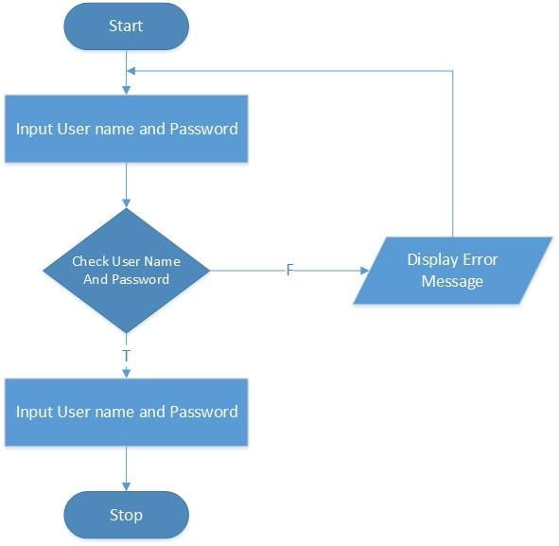

Fig:-Flowchart Diagarm of login page

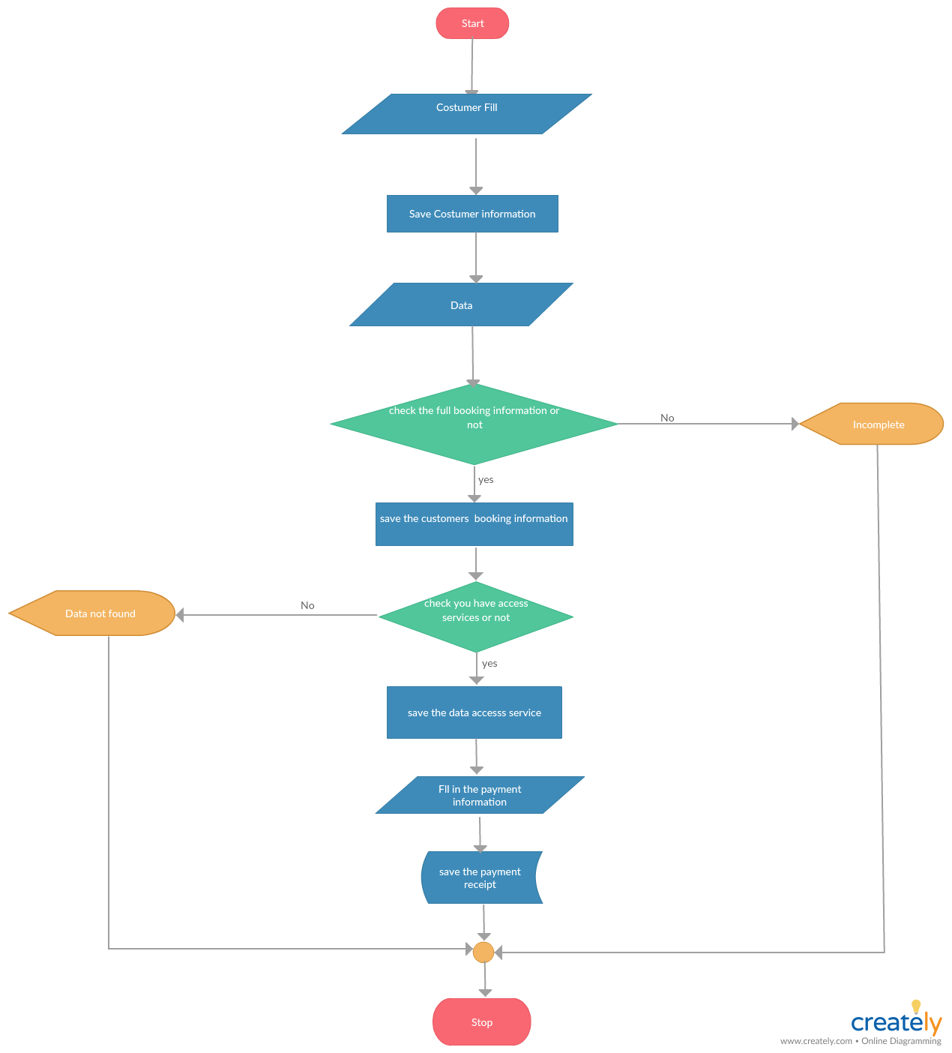

fig:-Flowchat of futsal Management system

**Data Flow Diagram**

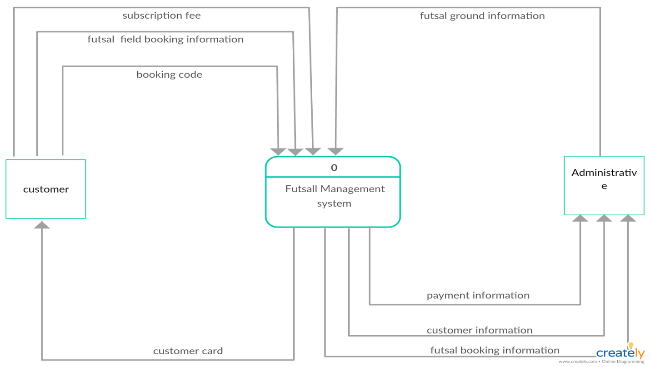

Fig:-context diagram

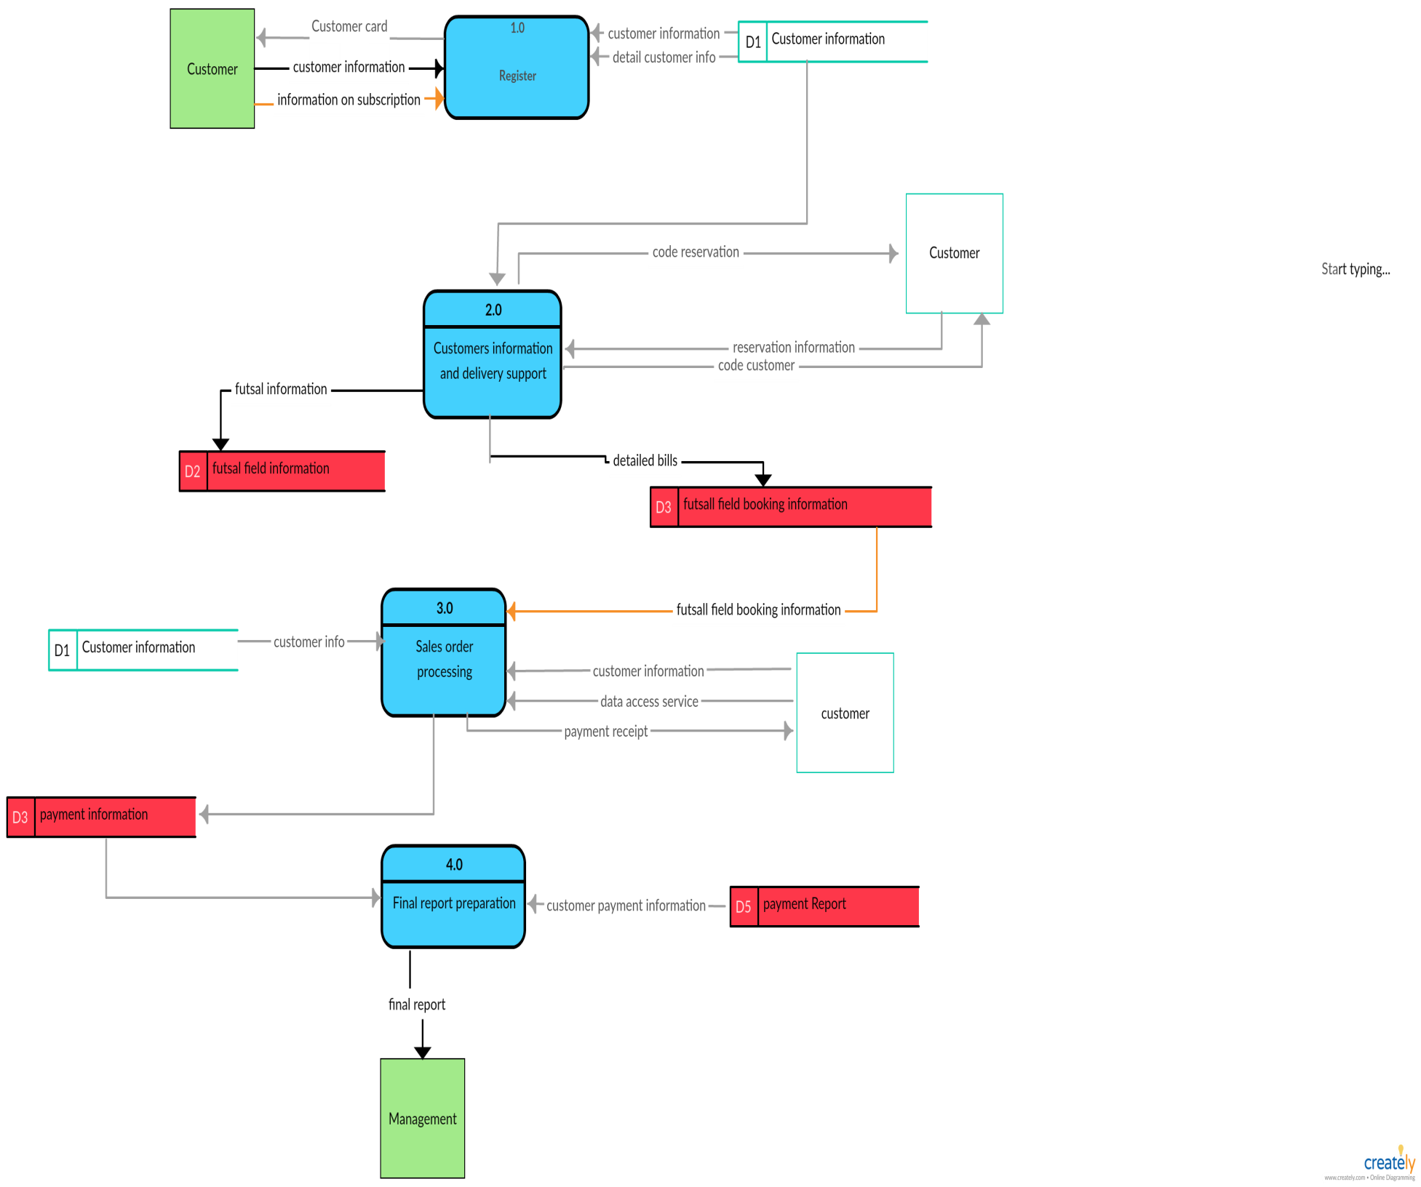

Fig:-Data Flow Diagram level1

**3.3 ER-Diagram**

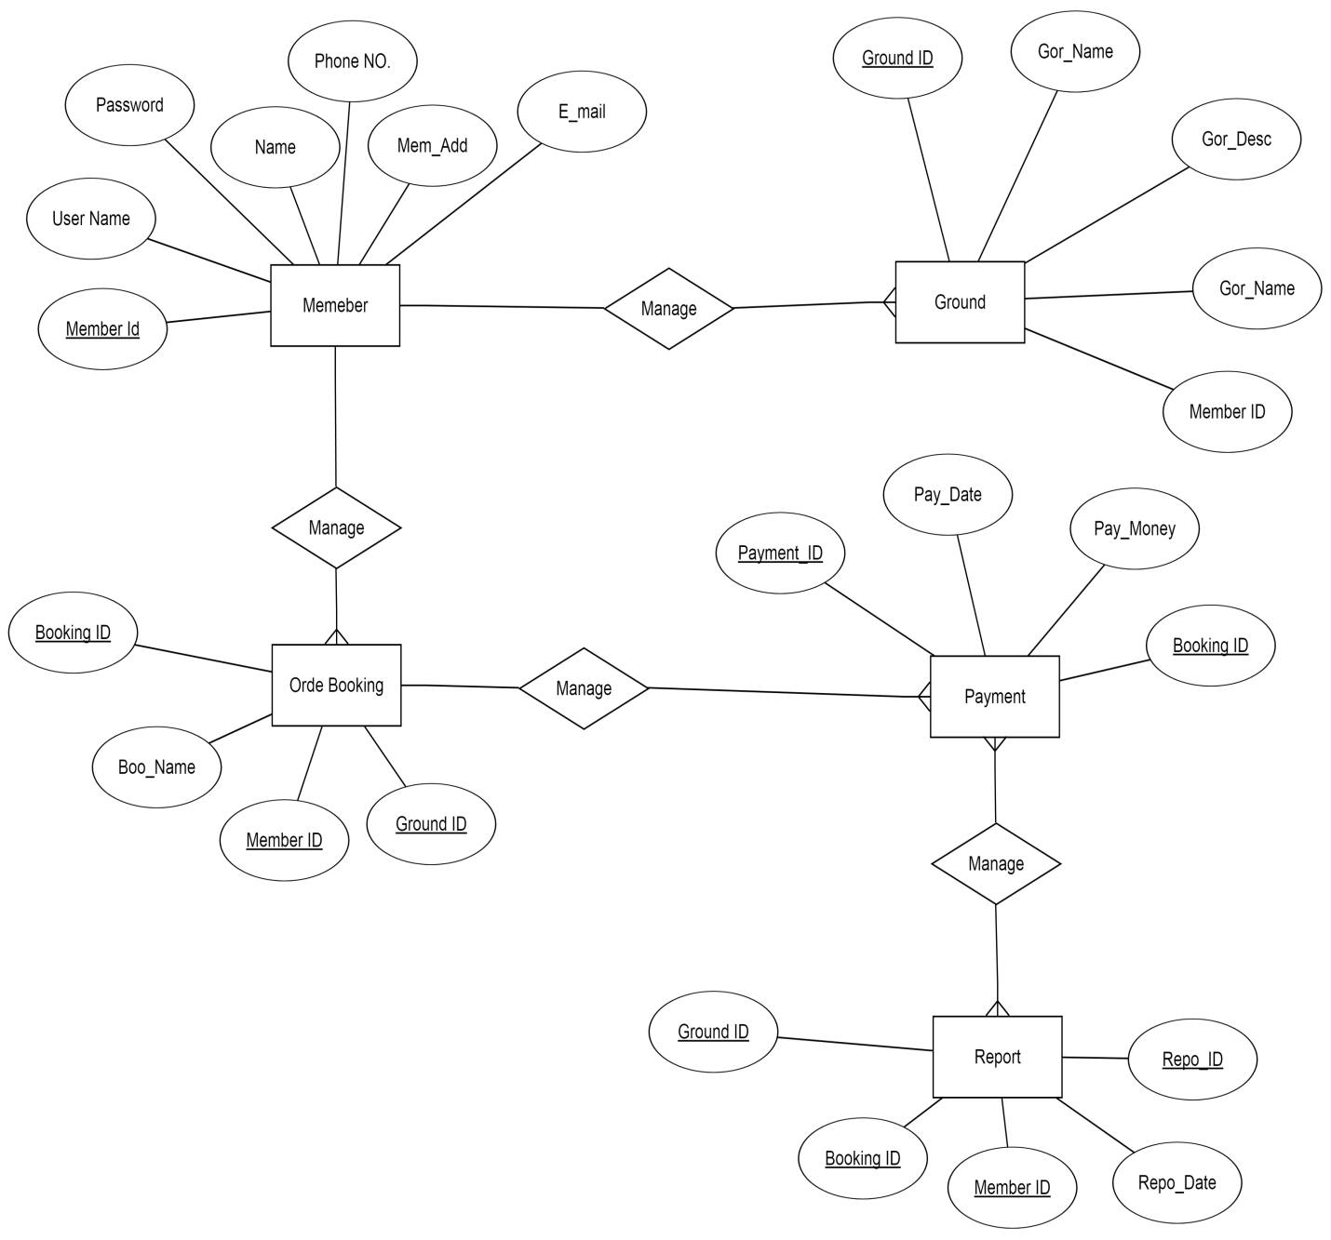

**RECOMMENDATION**

Always give it a try approach, before making comments I believe this system is a conceptual design, for a user .this system help to consume the time .it make work easier and faster it’s how he make efficient use of key presses, key release .

**6. Limitations**

**➢** Program might crash if not integers values are given to integer.

➢ Program only provides text-based interface

➢ Online based application not supported

➢ Lack of Secured data and Security

**7. CONCLUSION:**

Using this software recording process can be made standard, much easier and more effective in order to meet the satisfaction level of the people and make the task much efficient.Provide facility for identification and verification services through a booking system.

**8. BIBLIOGRAPHY**

https://creately.com/app/#

Project instructor and mentor Mr. Anaya Upadhyay help and guidance

<https://r3dux.org/2010/11/how-to-use-sql-connectorc-to-connect-to-a-sql-database-in-windows/>

:Bruce Johnson. (2014). Professional Visual Studio 2013.

Microsoft SQL Server 2014 Future and Features. United States : https://www.youtube.com/watch?v=YF9Kidp7qmI Esneyder Alvarez. (2014).

Conexion SQl server 2014 Visual Studio 2013 Asp. https://www.youtube.com/watch?v=s9vfSFTINxQ